Overview

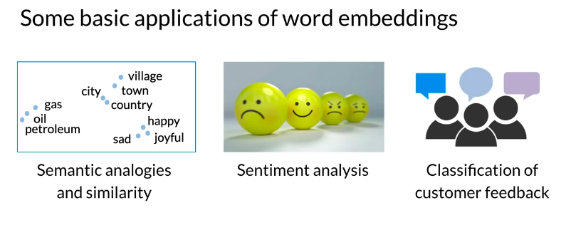

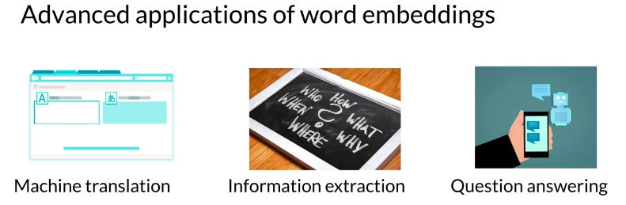

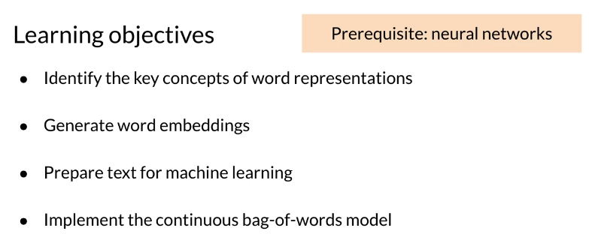

Basic Word Representations

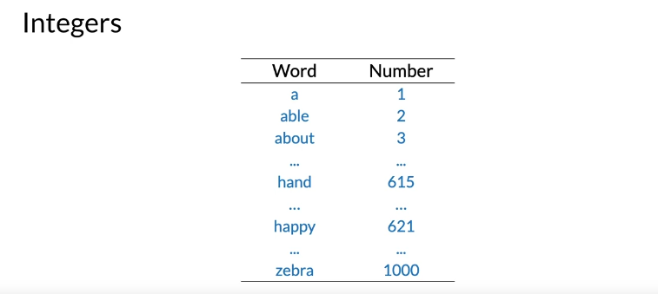

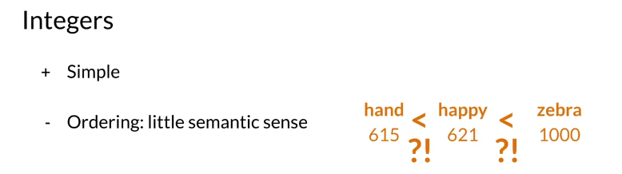

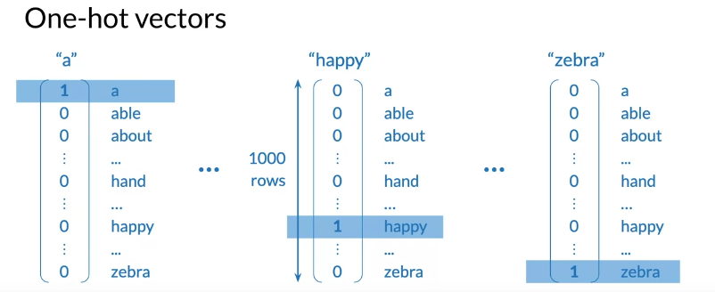

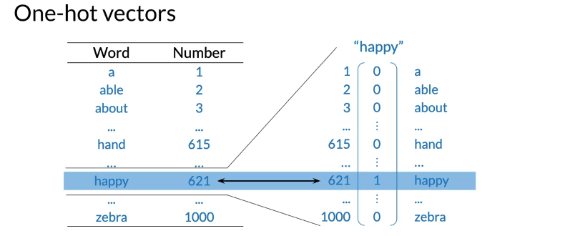

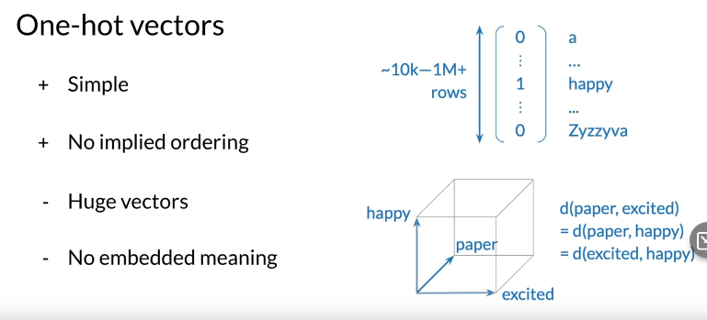

Word Embeddings

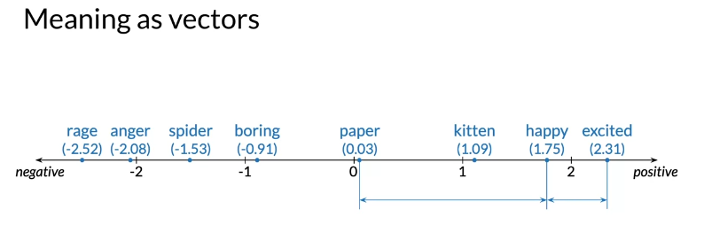

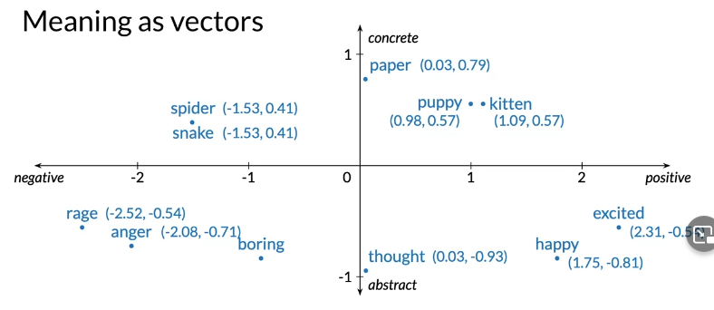

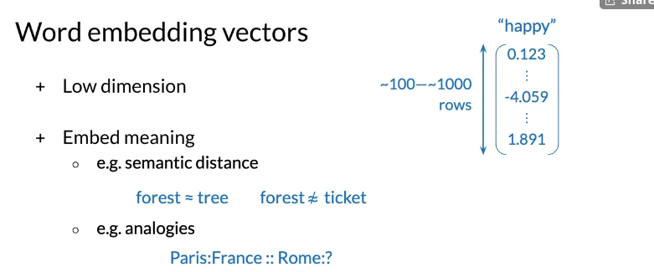

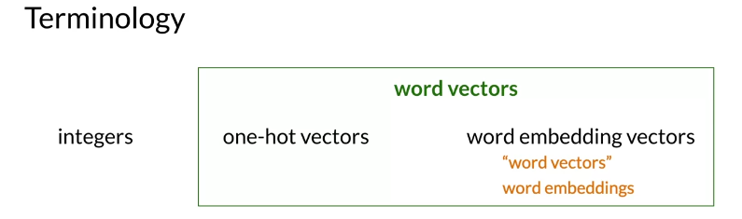

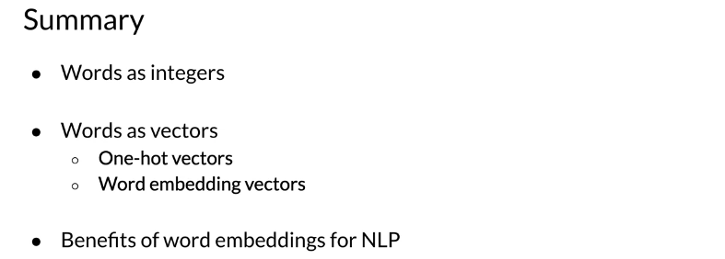

How to Create Word Embeddings
To create word embeddings you always need a corpus of text, and an embedding method.
The context of a word tells you what type of words tend to occur near that specific word. The context is important as this is what will give meaning to each word embedding.
There are many types of possible methods that allow you to learn the word embeddings. The machine learning model performs a learning task, and the main by-products of this task are the word embeddings. The task could be to learn to predict a word based on the surrounding words in a sentence of the corpus, as in the case of the continuous bag-of-words.
The task is self-supervised: it is both unsupervised in the sense that the input data — the corpus — is unlabelled, and supervised in the sense that the data itself provides the necessary context which would ordinarily make up the labels.
When training word vectors, there are some parameters you need to tune. (i.e. the dimension of the word vector

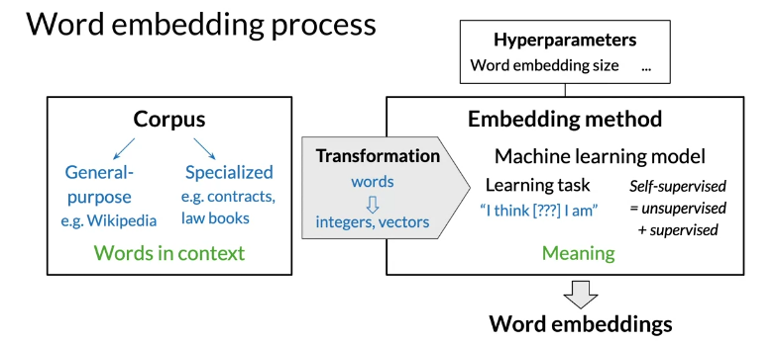

Word Embedding Methods

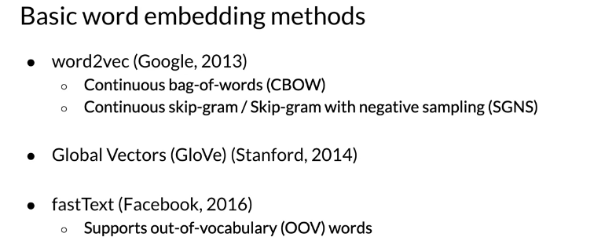
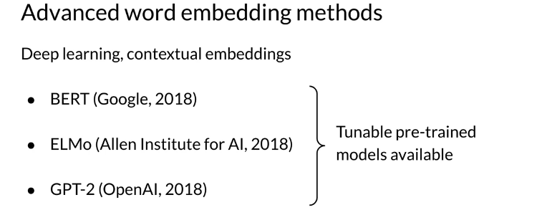

Continuous Bag-of-Words Model

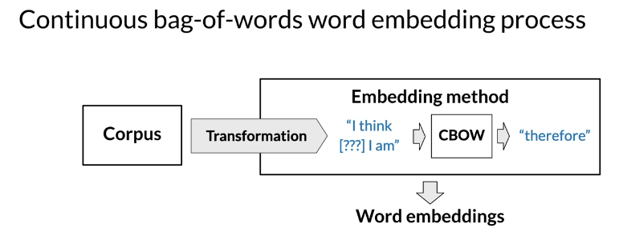
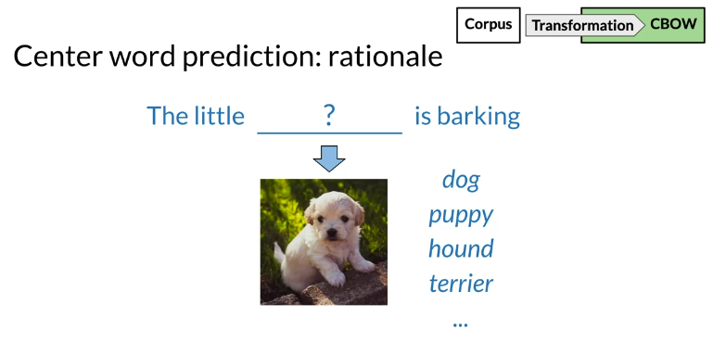
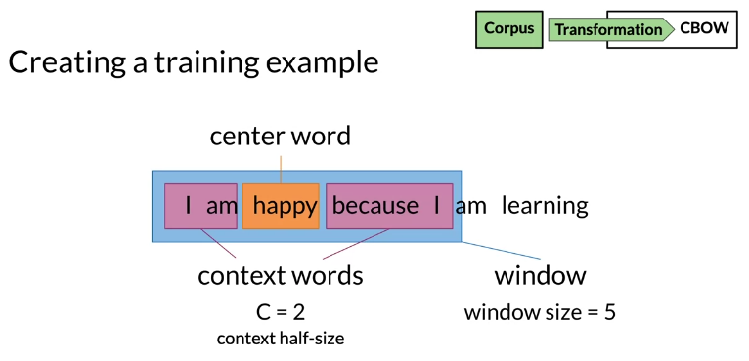
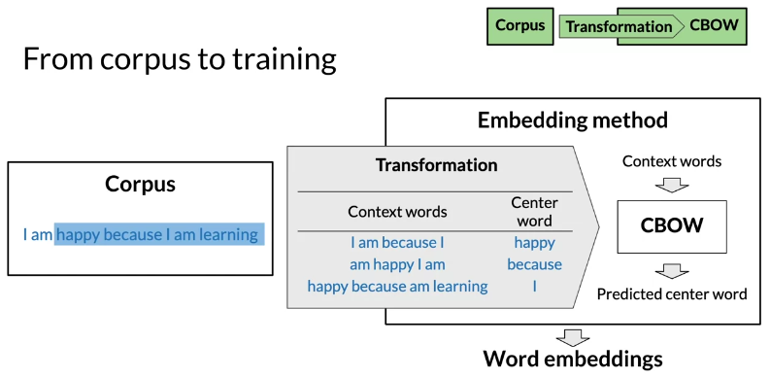

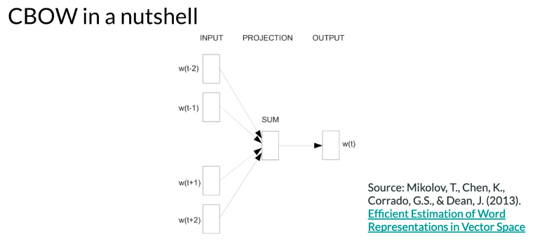

Cleaning and Tokenization

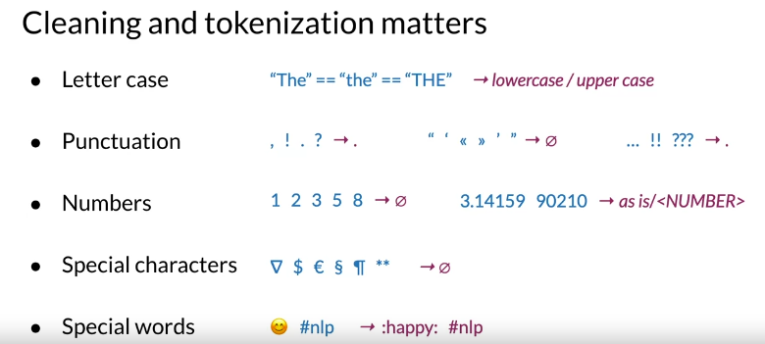
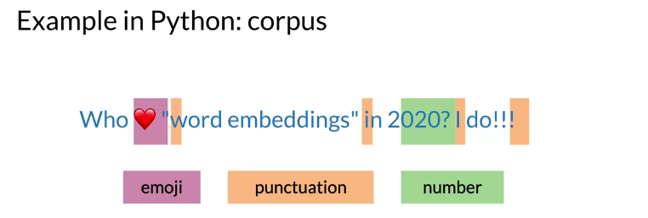
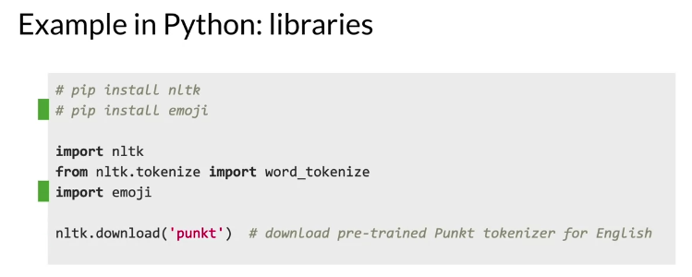

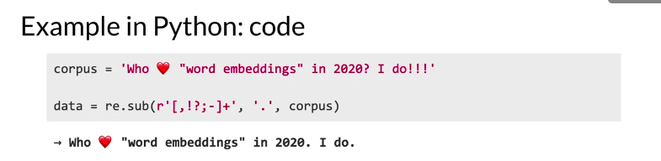

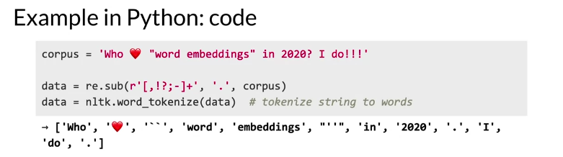

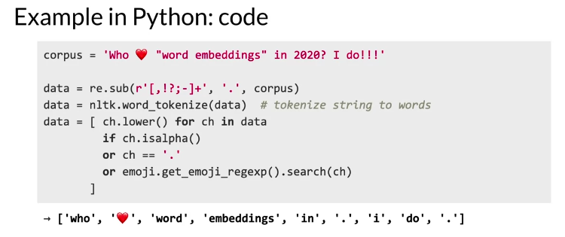

Sliding Window of Words in Python

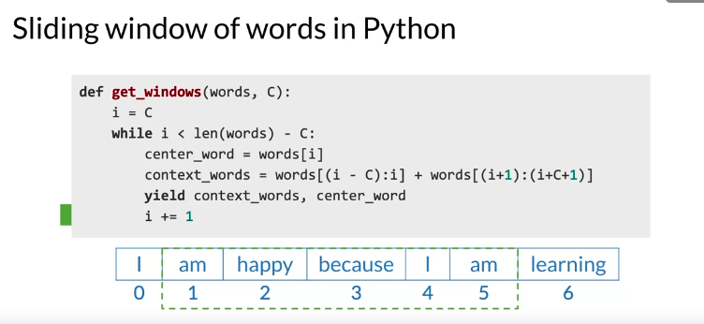

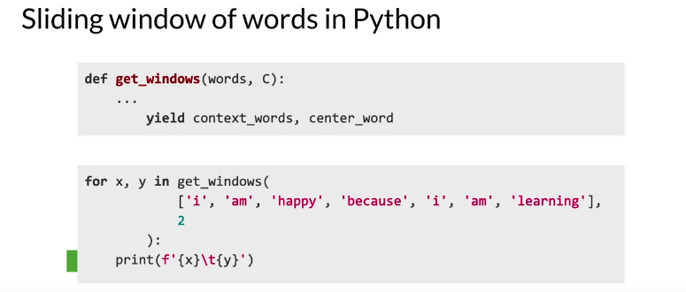

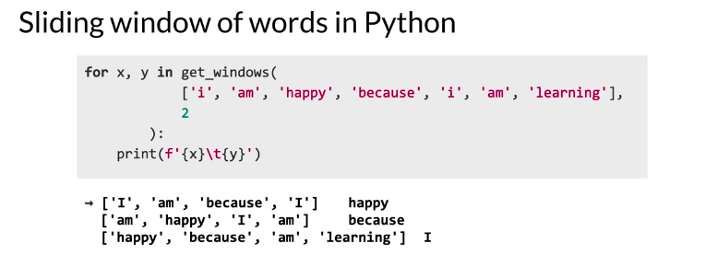

Transforming Words into Vectors

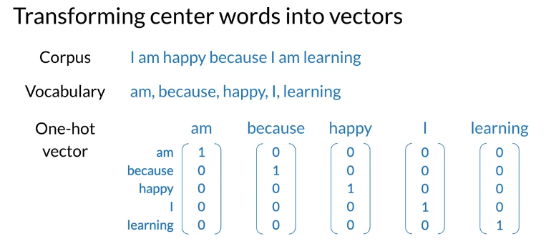

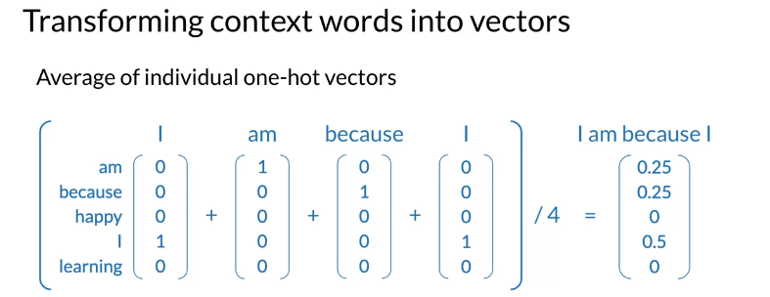
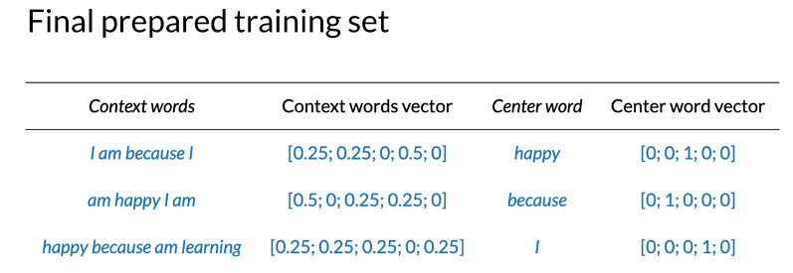

Architecture of the CBOW Model
The architecture for the CBOW model could be described as follows

You have an input, X, which is the average of all context vectors. You then multiply it by W1​ and add b1​. The result goes through a ReLU function to give you your hidden layer. That layer is then multiplied by W2​ and you add b2​. The result goes through a softmax which gives you a distribution over V, vocabulary words. You pick the vocabulary word that corresponds to the arg-max of the output.
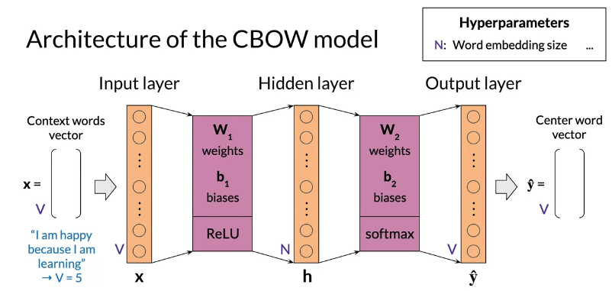

Architecture of the CBOW Model: Dimensions

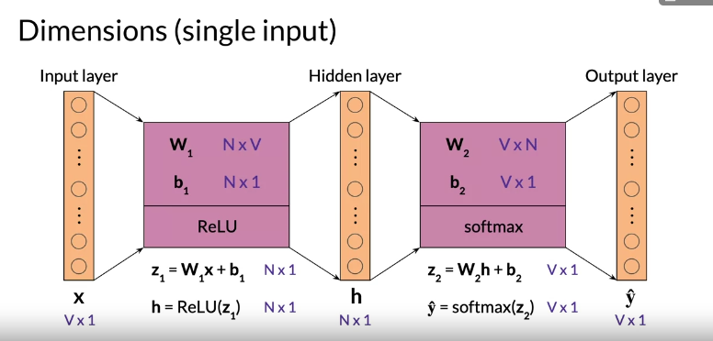

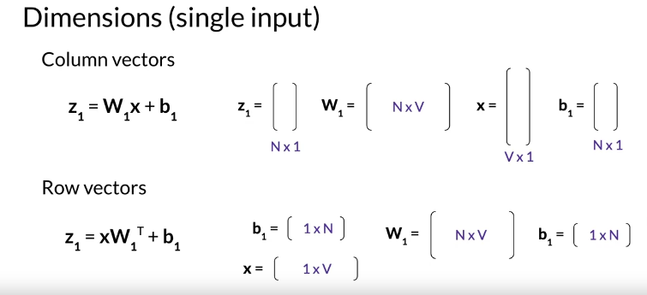

Architecture of the CBOW Model: Dimensions 2
When dealing with batch input, you can stack the examples as columns. You can then proceed to multiply the matrices as follows:

In the diagram above, you can see the dimensions of each matrix. Note that your Y^ is of dimension V by m. Each column is the prediction of the column corresponding to the context words. So the first column in Y^ is the prediction corresponding to the first column of X.

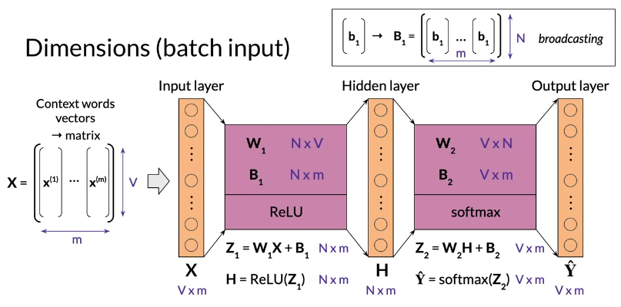
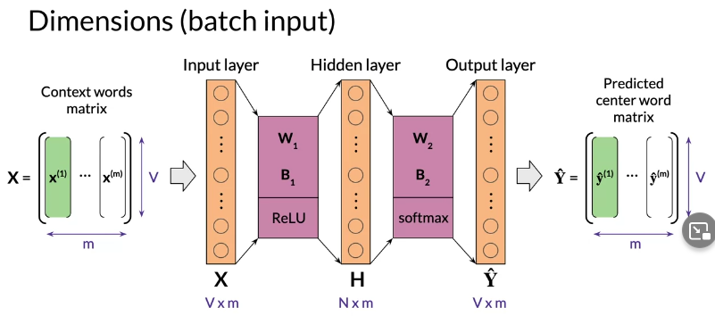

Architecture of the CBOW Model: Activation Functions

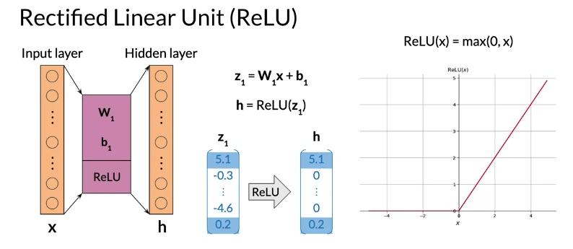
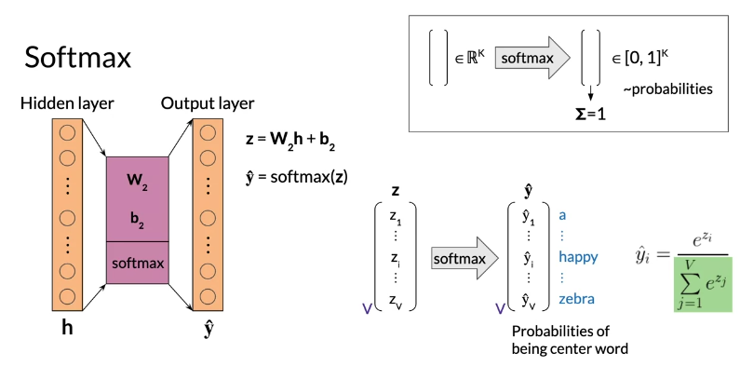

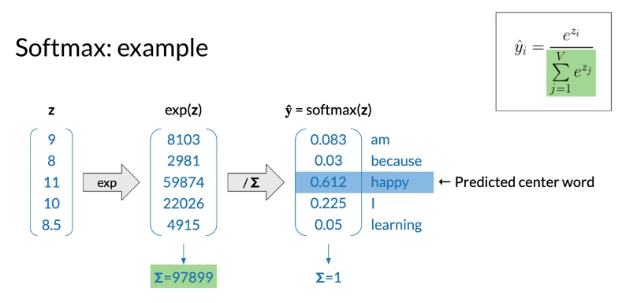

Training a CBOW Model: Cost Function

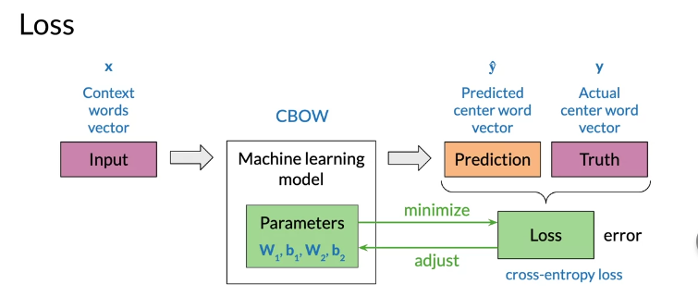
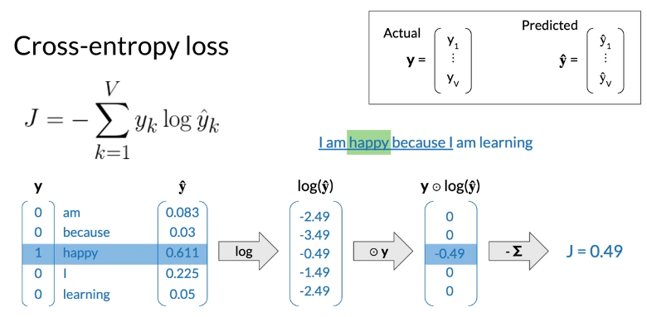
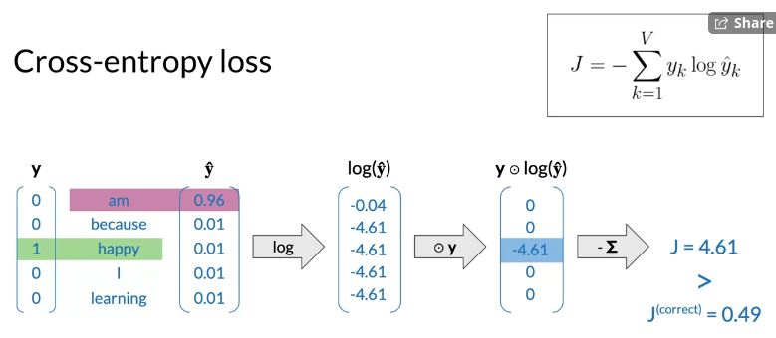
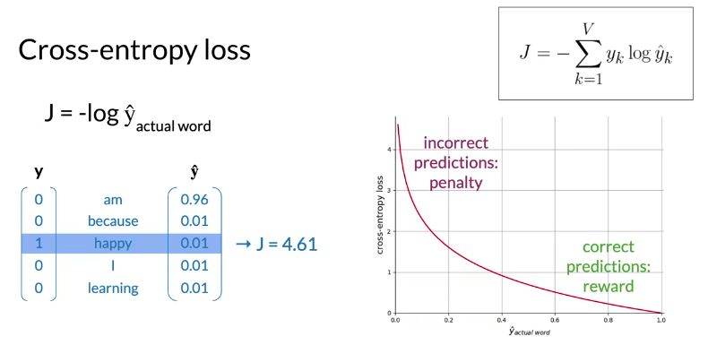

Training a CBOW Model: Forward Propagation

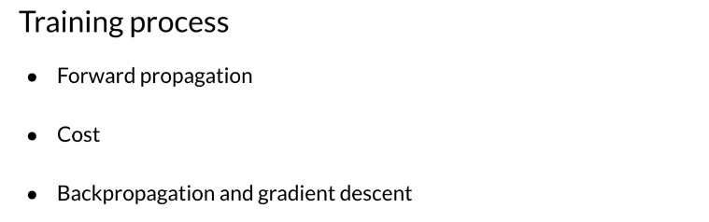
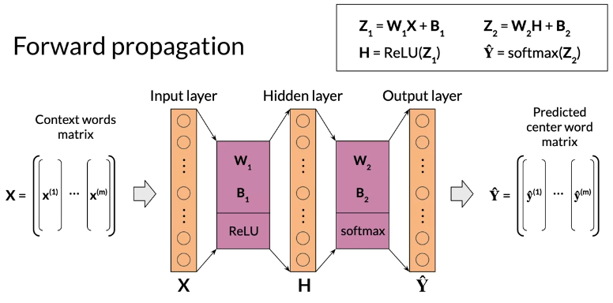
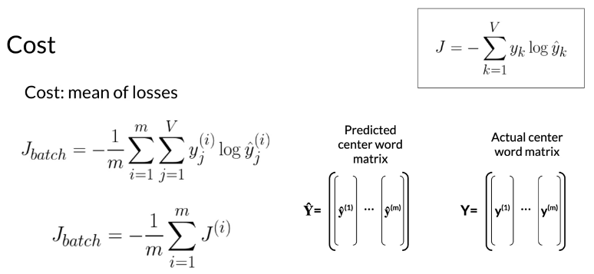

Training a CBOW Model: Backpropagation and Gradient Descent
Backpropagation: calculate partial derivatives of cost with respect to weights and biases.
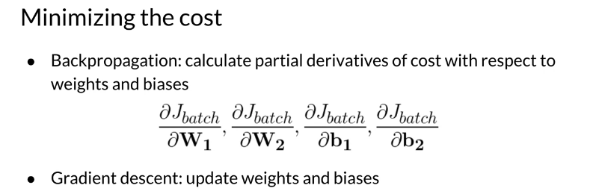
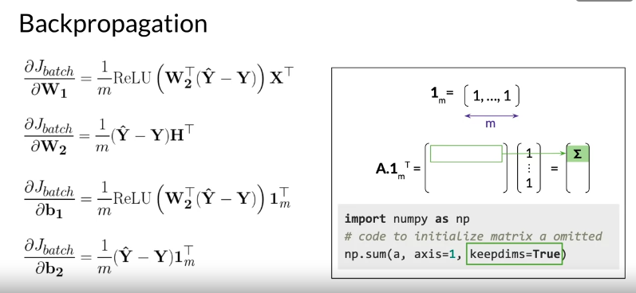
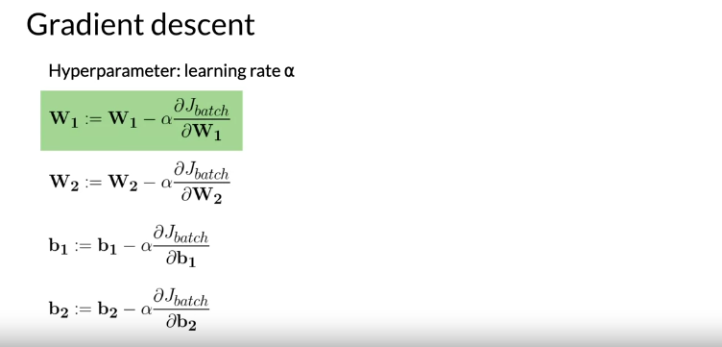

Extracting Word Embedding Vectors

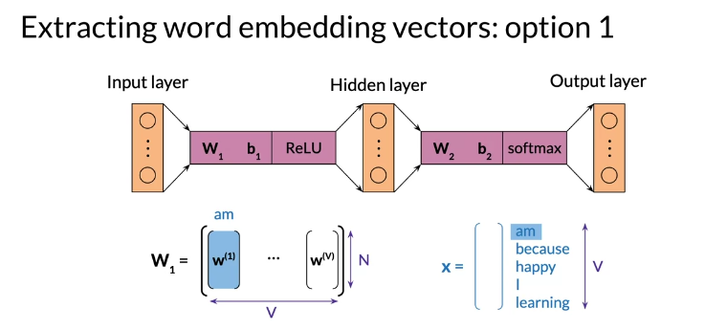

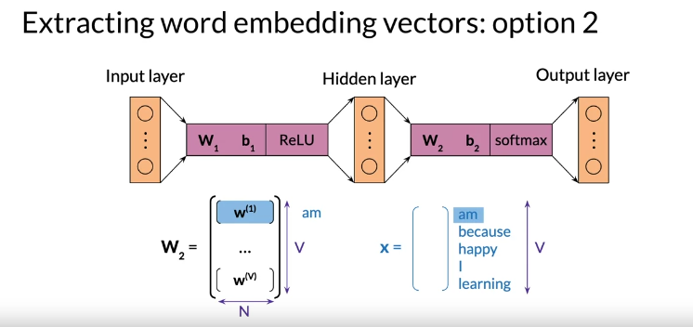
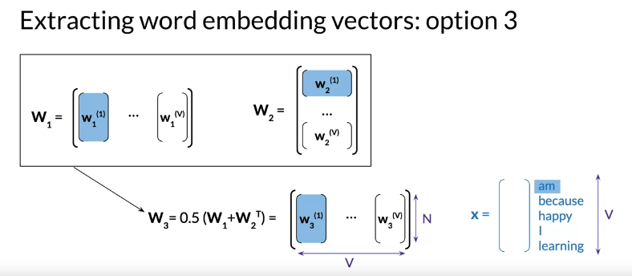

Evaluating Word Embeddings: Intrinsic Evaluation

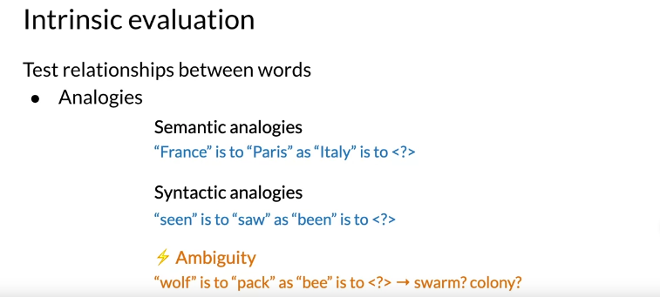
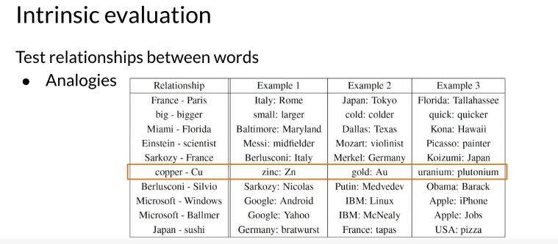
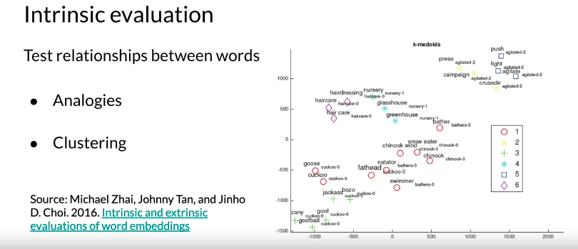
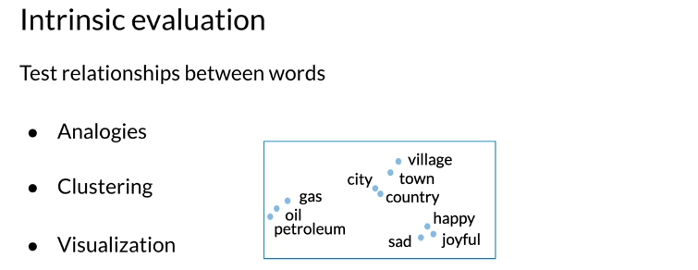

Evaluating Word Embeddings: Extrinsic Evaluation

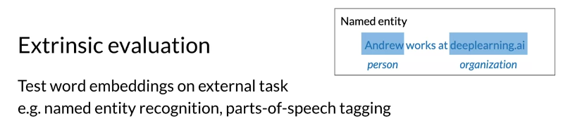
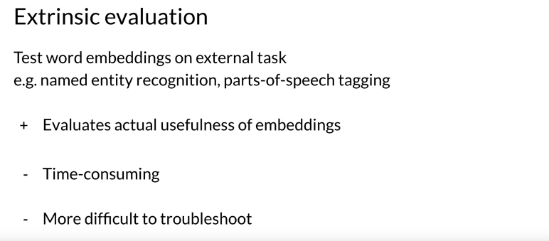

Conclusion



